 



**ONLINE COURSE:**

**BARCELONA SCREENING SCHOOL - CERVICAL CANCER SCREENING**

**M1 Cancer prevention - Author Templates**

# Highlights of the course

|  |  |
| --- | --- |
| Total modules | 8 modules |
| Approximate Hours | Total hours: 27,5 hours  **Module 1: 2,5 hours**  Module 2: 2,5 hours  Module 3: 4 hours  Module 4: 1,5 hours  Module 5: 8 hours  Module 6: 2,5 hours  Module 7: 1,5 hours  Module 8: 5 hours |
| Total number of pages to produce approximately | **Module 1: 12,5 word pages (not counting final evaluation,** **glossary and Bibliography)** |
| Number of characters per page | Five word pages of text correspond to one hour of online training.  Each page will be of 2,100 characters in Arial 10, 1.5 line spacing. |
| Delivery Date |  |
| Language | Preferably English |

BIOGRAPHICAL SKETCH OF THE AUTOR

**Paula Peremiquel-Trillas** holds a medical degree (Autonomous University of Barcelona, 2014) and a Master degree in Public Health (Pompeu Fabra University, 2017). She specialized in Preventive Medicine and Public Health (Vall d’Hebron University Hospital, 2019). During her specialization training she has done internships in the World Health Organization and in the Catalan Institute of Oncology (ICO) and she has been involved in different research projects in the field of vaccinology, virology, cancer epidemiology and community health.

In May 2019, she joined the Cancer Epidemiology Research Program (CERP) in the ICO as epidemiologist working on the Screenwide Project, which aims to early detect endometrial and ovarian cancers using genomic biomarkers. She is currently working on her PhD under Dr. Laura Costas supervision. She was awarded a Rio Hortega grant in 2020.

Paula is also an investigator in the randomized clinical trial evaluating the efficacy, immunogenicity and safety of 9v-HPV vaccine versus placebo in preventing persistent oral infection in adult men. Since January 2021, she is also assisting in the implementation of an organised HPV-based cervical cancer screening using self-sampling to be implemented in Catalonia.

**Laura Costas Caudet** is a medical doctor (Autonomous University of Barcelona, 2005) and holds a Master of Public Health (Pompeu Fabra University, 2007). She specialized in Preventive Medicine and Public Health (Clinic Hospital, 2010). In 2010, she obtained the Emili Letang End-of-Residency award from the Clinic Hospital in Barcelona.

In 2012, Laura joined IDIBELL were she conducted her PhD studies, obtaining a Cum Laude PhD in medicine (2012-2016). In her PhD, she studied the role of reproductive factors, hormone use and endocrine disruptors in the etiology of lymphoid neoplasms, under a Rio Hortega grant. In 2012, she spent a year at the McGill University in Montreal (Canada) and got valuable experience on the quantitative analyses of biases in epidemiologic studies. Afterwards, in 2016, she performed a research stay at the International Agency for Research on Cancer (IARC), in Lyon, France. At IARC, she worked at the Genomic Cancer Susceptibility group and was involved in a project aimed to evaluate risk factors and mutational patterns in nasopharyngeal cancer in Southeastern Asia.

In 2016 she joined the Catalan Institute of Oncology serving as a Principal Investigator for the Screenwide study. Screenwide is a project that aims to early detect endometrial and ovarian cancer based on the genomic exploitation of minimally invasive sampling methods, such as cervical cytologies and vaginal self-samples, and to explore risk factors for these cancers. As a result of her research, she counts with 45 publications in peer-reviewed journals.

Since 2015 she leads the “Mejor sin Cancer” platform aimed to the general public, which counts with 1000-1500/day readers and received the endorsement of the Sociedad Española de Oncología Médica (SEOM) and the Fundació Olga Torres award. She has also collaborated with the online training platform E-oncologia tutoring courses related to cervical cancer prevention.

**Structure of the course (12,5 pages)**

* + Introduction and Learning Objectives
  + Index
  + Contents
  + Summary

**Module 2: Cancer prevention**

# Title: Introduction and Learning Objectives

**[Introduction]**

Cancer is a major public health problem worldwide. Cancer is a leading cause of disease and death in many countries yet there is an important bulk of it that can be prevented. In particular those cancer sites that can benefit of an early detection, precancerous detection or primary prevention actions. In 2018, over 18 million of new diagnosed cancer cases occurred worldwide with more than 9.6 million of patients dying from cancer in that year.

Understanding the importance of screening is fundamental to develop strategies for specific cancer sites that lead to the identification of cancer cases earlier, even before the onset of signs and symptoms, leading to better prognosis outcomes and survival.

This module reviews general aspects of cancer screening, including the criteria that a good screening test needs and the overall requirements for a screening programme implementation.

**[Learning Objectives]**

At the conclusion of this course, participants will be able to:

* Understand cancer principles of screening,
* Identify types of screening programmes,
* Understand screening test characteristics,
* Learn overall requirements for screening programme implementation.

**[Index]**

1. Principles of screening

1.1. Natural history of the disease and types of cancer prevention

1.2. Wilson and Jungner 10 principles of screening

1. Test parameters and requirements

2.1. Criteria for a good screening test

2.2. Test accuracy and reliability

2.3. Potential biases in screening

3. Overall program characteristics

**Module 2: Cancer prevention**

# Unit: 1. Principles of screening

**1.1. Natural history of the disease and types of cancer prevention**

The natural history of the disease is the progression of a disease over time and understanding how it evolves is fundamental to learn what can we do to avoid its progression.

Many diseases have certain relatively well-defined and well-known stages in which different types of preventive measures can be applied [Figure 1].

Figure 1. Natural history of cervical cancer and types of preventive measures.

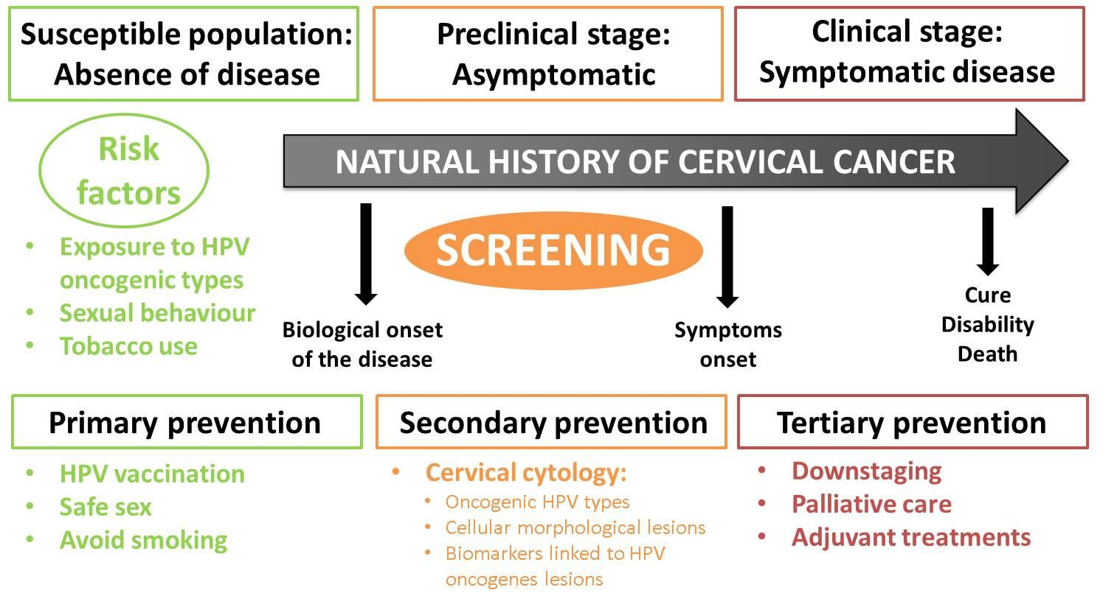

COLUMNA VERDA - The disease process begins with the exposure to risk and etiological factors in a susceptible host (1).

At this stage, *primary prevention* (2) focuses on protecting healthy individuals from the biological onset of disease by means of health promotion and health protection interventions. Therefore, primary prevention strategies aim to reduce the incidence of disease by eliminating exposure to risk factors or by increasing population resistance to risk factors.

In cervical cancer the main primary prevention action is avoiding exposure to oncogenic HPV types, the necessary cause of cervical cancer, through vaccination.

COLUMNA TARONJA - In some individuals, the disease process is triggered, and pathological changes start, normally without the individuals being aware of them (asymptomatic). This is known as the subclinical stage of the disease or the latency period.

At this stage, *secondary preventio*n *or screening* (2) consists of the systematic application of safe, easy-to-use and economically affordable tests, to provide early diagnosis of disease followed by timely treatment. Secondary prevention aims to identify the existence of health problems before they get worse, provide treatment at an early stage and to improve disease prognosis. Therefore, screening aims at reducing the disease prevalence by shortening its duration, reducing the incidence of complications associated with the disease and increasing the quality of life of those affected by the disease.

In cervical cancer, it can take decades for an HPV infection to progress to cancer. Therefore, secondary prevention consists of the detection of precancerous lesions caused by persistent infection of HPV using cytology or HPV testing.

COLUMNA VERMELLA - At some point, the disease start to be symptomatic and individuals look for medical assistance. Ultimately, the disease process ends either in recovery, disability or death.

*Tertiary prevention* aims to decrease the impact of an ongoing disease. It consists of managing the long-term disease (avoid complications and relapses) to reduce morbidity, disability and mortality among those diagnosed and being treated for the disease.

The presentation and course of cancer will vary in different individuals and contexts, even for the same disease. In cervical cancer, HPV infections may never progress to cancer for most women but in a few others the process may result in severe or fatal illness. This is called the spectrum of disease.

The table below shows the different strategies or interventions that are being used to prevent the exposure to HPV, its progression to cervical cancer and the mitigating measures once the cancer has been diagnosed.

[Examples]

|  |  |
| --- | --- |
| *Primary prevention* | * Vaccination against HPV oncogenic types * Condom use * Avoidance of sexual relations * Health information and warnings about tobacco use |
| *Secondary prevention* | * Detection of oncogenic HPV types (HPV testing) * Detection of cellular morphological lesions (cytology) * Detection of biomarkers linked to HPV oncogenes |
| *Tertiary prevention* | * Downstaging * Palliative care * Adjuvant treatments |

[Did you know?]A group of experts assessed the available evidence on cancer prevention to develop the European Code against Cancer (3), a list of 12 recommendations on actions that individual European citizens can take to help prevent cancer:

1. Do not smoke. Do not use any form of tobacco.
2. Make your home smoke free. Support smoke-free policies in your workplace.
3. Take action to be a healthy body weight.
4. Be physically active in everyday life. Limit the time you spend sitting.
5. Have a healthy diet:

* Eat plenty of whole grains, pulses, vegetables and fruits.
* Limit high-calorie foods (foods high in sugar or fat) and avoid sugary drinks.
* Avoid processed meat; limit red meat and foods high in salt.

1. If you drink alcohol of any type, limit your intake. Not drinking alcohol is better for cancer prevention.
2. Avoid too much sun, especially for children. Use sun protection. Do not use sunbeds.
3. In the workplace, protect yourself against cancer-causing substances by following health and safety instructions.
4. Find out if you are exposed to radiation from naturally high radon levels in your home. Take action to reduce high radon levels.
5. For women:

Breastfeeding reduces cancer risk. If you can, breastfeed your baby. Hormone replacement therapy (HRT) increases the risk of certain cancers. Limit use of HRT.

1. Ensure your children take part in vaccination programmes for:

* Hepatitis B (for new-borns)
* Human papillomavirus (HPV) (for girls)

1. Take part in organized cancer screening programmes for:

* Bowel cancer (men and women)
* Breast cancer (women)
* Cervical cancer (women)

Yet, successful cancer prevention requires these individual actions to be supported by governmental policies and actions.

For more information on the European Code Against Cancer please [check](https://cancer-code-europe.iarc.fr) this website (3).

**1.2. Wilson and Jungner 10 principles of screening**

Screening is the action of actively searching for a disease in an asymptomatic population. However, not all diseases can be screened. A disease should fulfil some requirements before it is considered as a candidate for screening (See box below).

In 1968, Wilson and Jungner enumerated ten principles to be considered before undertaking a screening program. These criteria are key in understanding the complexity and requirements of a screening program (4,5).

|  |  |  |
| --- | --- | --- |
|  | Wilson and Jungner principles | Translation into cervical cancer |
| 1. | The condition sought should be an important health problem. | Cervical cancer is the fourth most common cancer among women worldwide. In 2018, 570,000 women were diagnosed with cervical cancer and more than 310,000 died from this disease. |
| 2. | There should be an accepted treatment for patients with recognized disease. | Pre-invasive lesions at an advanced stage (CIN2+) can be treated via conization. In resource limited settings ablative methods can be used. |
| 3. | Facilities for diagnosis and treatment should be available. |
| 4. | There should be a recognizable latent or early symptomatic stage. | It can take decades from an HPV infection to progress to cancer. Within this latency period, both HPV infections and pre-invasive lesions can be detected. |
| 5. | There should be a suitable test or examination. | Pap smear and HPV detection are effective methods to detect preclinical phases. |
| 6. | The test should be acceptable to the population. | Cervical sampling by a clinician or through self-samplingare generally acceptable to women. |
| 7. | The natural history of the condition, including development from latent to declared disease, should be adequately understood. | The continuum of disease from an HPV infection to cervical cancer is well understood. |
| 8. | There should be an agreed policy on whom to treat as patients. | In the case of an abnormal tests, specific protocols for referral and treatment exist. |
| 9. | The cost of case-finding (including diagnosis and treatment of patients diagnosed) should be economically balanced in relation to possible expenditure on medical care as a whole. | Cost-effectiveness of cervical cancer screening program have generally demonstrated a favourable cost-effectiveness balance. |
| 10. | Case-finding should be a continuing process and not a “once and for all” project. | Screening programs demand a systematic approach with specific multidisciplinary guidelines and quality control procedures. |

The target disease should be an important health problem, either for its frequency or for its severity. The natural history of the disease needs to be well-understood and there should be sufficient data on the incidence and prevalence of the disease in a specific setting, as well as evidence on the association between disease markers and progression (natural history of disease) and the implications (clinical, psychological, economical) of resulting positive in the screening test.

Besides these classic criteria, additional programmatic criteria are also critical:

* The screening programme should respond to a recognized need.
* The objectives of screening should be defined at the outset.
* There should be a defined target population.
* There should be scientific evidence of screening programme effectiveness.
* The programme should integrate education, testing, clinical services and programme management.
* There should be quality assurance, with mechanisms to minimize potential risks of screening.
* The programme should ensure informed choice, confidentiality and respect for autonomy.
* The programme should promote equity and access to screening for the entire target population.
* Programme evaluation should be planned from the outset.
* The overall benefits of screening should outweigh the harm

**Module 2: Cancer prevention**

# Unit: 2. Test parameters and requirements

## 2.1. Criteria for a good screening test

Screening tests are applied to subjects without clinical symptoms of disease. Therefore, potential tests need to be evaluated carefully in order to limit the potentially negative consequences on health outcomes (delay at diagnosis, false positive results, etc) and health system expenditures.

Thus, a screening test needs to be (6):

* Accurate: the test detects disease and classifies correctly those subjects that are ill and those who are not.
* - Reliable/reproducible: the test provides the same result consistently when repeated and when performed in different settings.
* - Cheap: the test is affordable for the health system and is useful to reduce the associated costs to the disease (monetary and non-monetary).
* - Accessible: The patients and their families have access to the screening test and subsequent procedures. Also, the steps are clear and easy to follow.
* - Acceptable: patients and providers well tolerate the screening test. A screening test must be acceptable to the population, easy-to-use, and cause minimal discomfort.
* Simple: the test is easy to use, and the results' management is straightforward and easy to follow.

Safe: the screening test procedure is secure, and the patients who result positive from the screening have minimal adverse effects. Screening can result in harmful effects associated with the screening test, which need to be considered, quantified, and evaluated. Potential harms in cervical cancer screening include physical harms (such as pain or bleeding due to the screening or diagnostic tests), psychological harms (such as anxiety due to a positive result), or those related to false positive (such as unnecessary harms and tests) and false-negative results (undiagnosed disease) (13). [Summary table 1]. Potential harms of cervical cancer cancer screening programs.

|  |
| --- |
| Overtreatment |
| Unnecessary distress, anxiety |
| False security of a negative result |
| Undertreatment due to lack of follow up or false negatives |

## 2.2 Test accuracy and reliability

When a test is performed, an individual can be classified as positive or negative.These results are compared with the results of a reference test or gold standard, which is the most reliable test available to confirm disease to obtain the test accuracy measures.

**[Example]** In cervical cancer, a positive screening results is generally followed by a confirmatory test and by biopsy of cervical samples if both test are positive, to provide the instruction for which treatment modality is best.

Test accuracy measures inform about the test ability to:

1. Discriminate health and disease status: classification of people between those who are ill and those who are not.
2. Predict disease: estimation of the probability of having or developing disease following a positive or negative result.

The principal measures of test accuracy are:

* sensitivity and specificity
* positive and negative predictive value (PPV/NPV)
* likelihood ratios (LR)
* the area under the curve (AUC) in the receiver operating characteristics (ROC) curve
* overall diagnostic accuracy

Tested subjects, according to their tests results and their disease status, are classified in four groups:

* **True positive (TP):** ill persons detected by the test.
* **False positive (FP):** healthy subjects incorrectly classified as positive by the test.
* **False negative (FN):** ill persons **not** detected by the test.
* **True negative (TN):** healthy subjects correctly classified by the test.

This information can be displayed as it is shown in table 1.

Table 1. Test results according to disease status.

|  |  |  |  |
| --- | --- | --- | --- |
|  | **Gold standard / Reference test** | |  |
|  | ***Subjects with***  ***the disease*** | ***Subjects without***  ***the disease*** | ***Total*** |
| ***Test Positive*** | **TP** | **FP** | TP + FP |
| ***Negative*** | **FN** | **TN** | FN + TN |
| ***Total*** | TP + FN | FP + TN | Total |

Example: Cervical cancer screening involves categorizing asymptomatic populations in four groups in relation to our gold standard (generally biopsy) and a screening test (HPV test). These four groups are:

* TP - those with cervical cancer that test HPV positive
* FP - those without cervical cancer that test HPV positive
* FN - those with cervical cancer that test HPV negative
* TN - those without cervical cancer that test HPV negative

|  |  |  |  |
| --- | --- | --- | --- |
|  | **Biopsy** | |  |
|  | ***Women with cervical cancer*** | ***Women without***  ***cervical cancer*** | ***Total*** |
| ***Positive HPV test*** | **TP** | **FP** | TP + FP |
| ***Negative HPV test*** | **FN** | **TN** | FN + TN |
| ***Total*** | TP + FN | FP + TN | Total |

***Sensitivity and specificity***

Sensitivity and specificity are the measures used for health and disease status discrimination (7):

* Sensitivity measures the percentage of diseased that test positive

Sensitivity = TP / (TP+FN)

* Specificity is the percentage of disease-free women who test negative.

Specificity = TN / (FP+TN)

[Practical exercise 1] 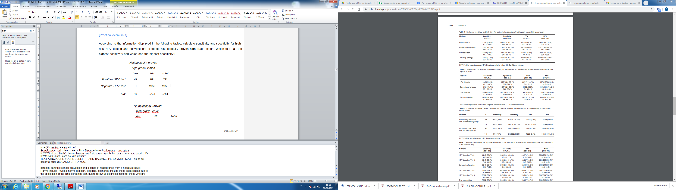According to the information displayed in the following tables, calculate sensitivity and specificity for high-risk HPV testing and conventional cytology to detect histologically proven high-grade lesion. Which test has the highest sensitivity and which one the highest specificity?

Answer: HPV test identifies all high grade lesions as positive while Cytology is missing 15 cases.

HPV test will category as positive 284 women with no evidence of high grade, while cytology will do so for 104 women. Thus, specificity is higher fro cytology as compared to HPV when both are compared to histological results

FALTA TEXT DE RESPOSTA AMB RESOLUCIO D’EXERCICIS. POSAR REFERENCIA D’ARTICLE

A perfect test will classify all women either as TP or TN (100% sensitivity and 100% specificity). However, tests rarely classify all subjects correctly according to their disease status since there is an overlap of the distribution of patients with disease with those that don’t have it. there are no perfect tests therefore our efforts will be directed to minimize false results (FP and FN).

The aim of a screening test is to have the highest sensitivity and specificity but, usually when one increases the other decreases [Figure 2]. If we choose the cut-off A (100% sensitivity), we will be detecting all subjects with a disease but half of the subjects without disease will be referred to unnecessary tests. The opposite occurs at cut-off C, to avoid sending subjects without disease to unnecessary tests (100% specificity), we would miss half of the subjects with disease.

Figure 2. Distribution of disease and non-disease with diagnostic cut-off values and subsequent effects on sensitivity and specificity.

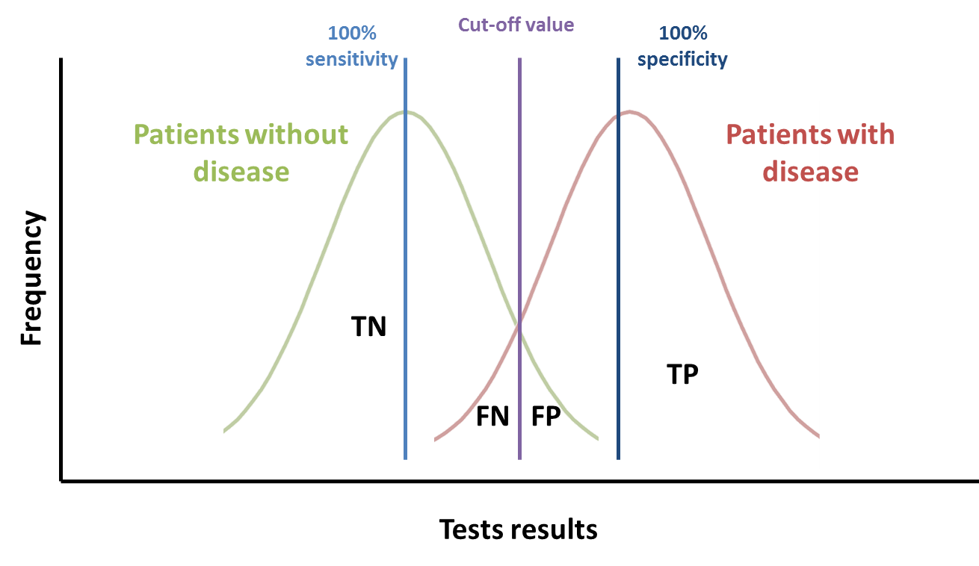

**[Example]** HPV tests aim to detect HPV persistent infections as the etiological factors for cervical precancer and cancer. However, because we still cannot differentiate acute with persistent infections, we may sometimes identify an HPV infection that will clear spontaneously and not causing disease.

[IMPORTANT] An ideal screening test should have the maximum sensitivity and specificity, but in real life this is almost impossible to accomplish, and screening tests do not classify patients perfectly. The prevalence of the majority of tumours among the general population is low. Therefore, a low test specificity results in a considerable proportion of false positives, leading to higher costs and adverse effects. In real life, the decision of the screening test might also consider whether additional diagnostic tests are available or not. In life-threatening diseases such as cancer, the main interest is that the subjects with disease are referred for further diagnosis, therefore a high sensitivity is needed to discard that participants are classified as false negatives. In general terms, we may prefer a test with higher sensitivity at the cost of reducing specificity. Additional tests are generally performed in screen positives aiming to at reduce unnecessary referrals for final diagnosis and/or treatment by increasing specificity. This step is called TRIAGE.

***Predictive values***

Clinicians are generally interested in the detection or absence of disease based on the results of the test being applied. Predictive values denote the probability that the test gives the correct diagnosis (8):

From the 2 by 2 table (Table 1), we can compute predictive values as follows.

- PPV measures the probability of presence of disease when the test is positive (proportion of patients with a positive test result that are correctly diagnosed). Low PPV values indicate a substantial number of unnecessary subsequent testing, important in the event of performing invasive tests in FP subjects.

PPV = TP / (TP+FP)

- NPV measures the probability of absence of disease when the test is negative, the proportion of patients with a negative test result that are not ill.

NPV = TN / (TN+FN)

[Practical exercise 2] According to the information displayed in the following tables, calculate the PPV and the NPV for high-risk HPV testing and conventional cytology.

FALTA RESPOSTA SOLUCIO A EXERCICI + LA REFERENCIA

Predictive values are affected by disease prevalence. The PPV of a test increases with increasing prevalence, while the NPV decreases with increasing prevalence of disease. Both increase with severity of disease (9). Therefore, PPV and NPV from one study should not be transferred to other settings with difference prevalence of disease. As well, careful interpretation should be done of test accuracy conducted in referred populations after a positive screening test result where the prevalence of disease is higher.

Sensitivity and specificity have been traditionally regarded as constant benchmarks of test performance and they are frequently used to compare the diagnostic value of different tests. Nevertheless, sensitivity and specificity, are also affected by disease prevalence (9).

When the prevalence of the disease is very low, the PPV will be substantially low even if sensitivity and specificity are high. Therefore, many people with a positive result who do not have the disease (false positives) will unnecessarily undergo subsequent testing.

***Likelihood ratios***

From sensitivity and specificity we can obtain the LR, which summarises how many times more (or less) patients with the disease are likely to have a particular result than patients without the disease (10).

* A positive likelihood ratio (LR+) indicates how many times more likely a positive test occurs in subjects with the disease than in those without the disease. The farther LR+ is from 1, the stronger evidence for the presence of the disease. LR above 10 are considered to provide enough strong evidence to confirm diagnosis in most of the circumstances. If LR+ is equal to 1, the test is not able to distinguish ill from healthy individuals.

LR+ = Sensitivity / (1-Specificity)

**[important]** A high LR+ indicates that the test is useful, but it does not necessarily indicate that a positive test is a good indicator of the presence of disease.

* A negative likelihood ratio (LR-) indicates how much less likely the negative test result is to occur in a subject with the disease than in a healthy subject. When LR is below 0.1, it is considered to provide enough evidence to exclude diagnosis in most of the circumstances. The lower LR- is, the stronger the evidence for the absence of disease.

LR- = (1-Sensitivity) / Specificity

Since sensitivity and specificity are used to calculate the LR, both LR+ and LR- depend again on disease prevalence.

[Practical exercise 3]According to the results obtained in previous exercises, and with the information in the following table, calculate the LR+ and LR- for high-risk HPV testing.

FALTA RESPOSTA / SOLUCIO A EXERCICI + REFERENCIA

Sensitivity= 1 Specificity= 1950/2234=0.87 LR+= 7.69 LR-=0.99

Likelihood ratios range from zero to infinity. The higher the value, the more likely the patient has the condition. As an example, let’s say a positive test result has an LR of 9.2. This result is 9.2 times more likely to happen in a patient with the condition than it would in a patient without the condition.

A rule of thumb (McGee, 2002; Sloane, 2008) for interpreting them:

0 to 1: decreased evidence for disease. Values closer to zero have a higher decrease in probability of disease. For example, a LR of 0.1 decreases probability by -45%, while a value of -0.5 decreases probability by -15%.

1: no diagnostic value.

Above 1: increased evidence for disease. The farther away from 1, the more chance of disease. For example, a LR of 2 increases the probability by 15%, while a LR of 10 increases the probability by 45%. An LR over 10 is very strong evidence to rule in a disease.

***Receiver Operating Characteristic (ROC) curve***

Many diagnostic tests are quantitative and a cut-off point has to be established to distinguish health and disease status. The ROC curve is the representation of all the pairs of sensitivity and specificity values for all the cut-offs that could be established in the test evaluated.

On the ROC curve, the x-axis represents 1-specificity (the false positive rate) while the y axis represents sensitivity (true positive rate) [Figure 3]. The shape of the ROC curve as well as the area under the curve (AUC) allows the estimation of how high the discriminative power of a test is: the closer the curve is located to the upper-left corner (highest sensitivity and specificity), the larger the AUC is and, therefore, the better the test is at discriminating health and disease. An AUC of 1 represents the perfect test, with 100% sensitivity and 100% specificity. An AUC of 0.5 represents a worthless test that does not allow discrimination (sensitivity is 50% and specificity is 50%), which is similar as tossing a coin.

Figure 3. Example of ROC curves and AUC.

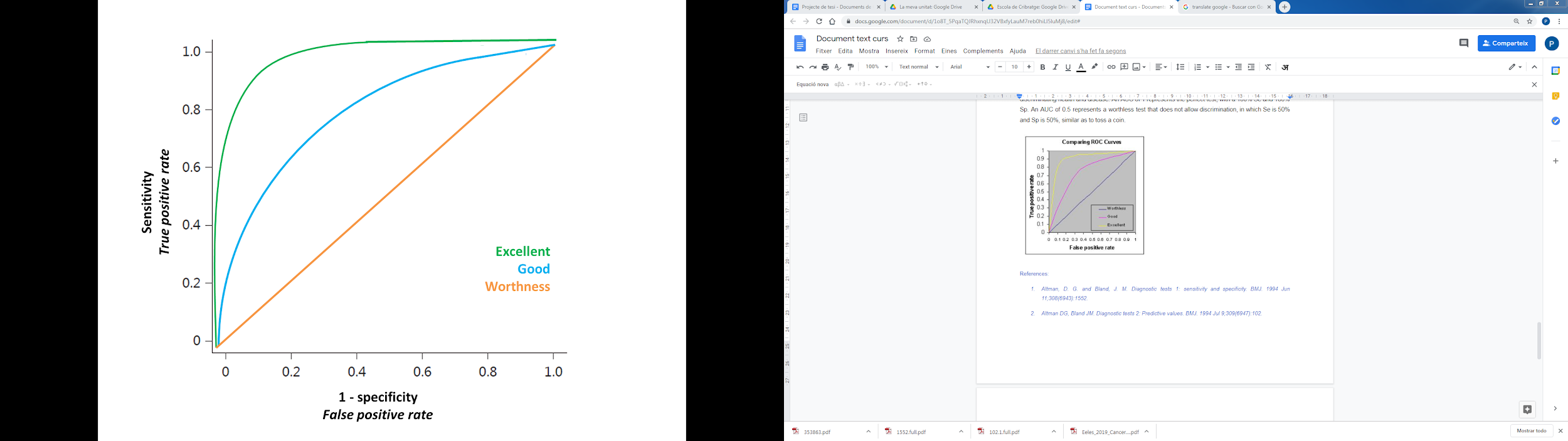

[Practical exercise 4]. According to the following ROC curves and AUC estimations, for Hybrid Capture II test used in the screening and diagnosis groups with CIN2/3 or worse. Can you indicate in which group of patients the test performs better to distinguish disease status (i.e. CIN2/3 or worse)?

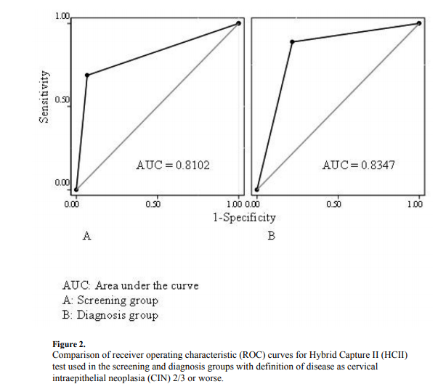

FALTA RESPOSTA / SOLUCIO A EXERCICI

***Overall diagnostic accuracy***

Finally, the overall diagnostic accuracy of a test is a global measure of the proportion of patients correctly identified among the total amount of subjects:

Overall diagnostic accuracy = (TP + TN) / total subjects

This measure is also affected by disease prevalence, and it increases as the disease prevalence decreases.

**[Important]** For all test accuracy measures (sensitivity, specificity, PPV, NPV, LR+, LR-, and overall diagnostic accuracy), it is fundamental to report the results using uncertainty measures such as 95% confidence intervals.

[Practical exercise 5]. Regarding to the Practical exercise 1, which test (high-risk HPV testing or conventional cytology) would you use for screening and which one for triage?[ANSWER] *High-risk* *HPV DNA for primary screening followed triage testing with cytology* (11)*.* In high-resource countries, high-risk HPV testing with triage with cytology is a standard procedure for early diagnosis of cervical cancer. High-risk HPV DNA testing shows high sensitivity and moderate specificity, while cytology has low to moderate sensitivity but very high specificity, and therefore is used as a triage test. Due to the moderate specificity of high-risk HPV testing, if all positive subjects underwent colposcopy, this would result in an excess of women undergoing testing and its associated costs (low PPV). To increase PPV, a high specific test like cytology (triage) is used so PPV is improved.

## 2.3. Potential biases in screening

### Once screening tests are well validated and applied to human populations, to properly assess the impact or effectiveness of screening programs there are some biases to be considered.

### *Lead time bias*

Screening allows identifying disease earlier, so treatment can start at an early phase in order to imply a longer survival. However, this jump in the detection of the disease may imply a bias. A screening program is not useful when there is an increase in survival but not a prolongation in life (i.e., die at the same time point as if not diagnosed earlier) (2). For example, consider two subjects with a similar natural history of disease, subject A is not screened whereas subject B is. Subject B appears to survive longer than subject A, but only because the disease was identified earlier [Figure 4].

Figure 4. Lead time bias.

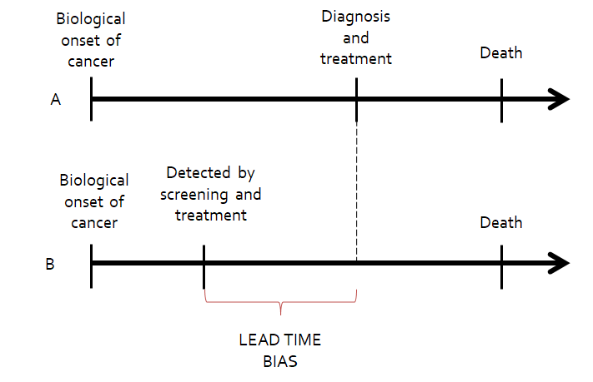

### *Length time bias*

Some cancers may have longer detectable preclinical phases than others, while others may be more aggressive and rapidly progress (2). Screening will probably detect those cancers with longer detectable preclinical phases, which are more likely to be more indolent than those that are not detected by screening [Figure 5]. Therefore, this could result in an increase in diagnoses (at higher cost, and potential harms and side effects of diagnosis and treatments) but not in a reduced mortality because these cancers would never have resulted in death.

Overdiagnosis bias is an extreme form of length-time bias (12). The detection of very indolent tumours in the screened group produces apparent increases in the number of cancer cases. Randomised trials with mortality rates as the endpoint can overcome lead and length-time biases.

Figure 5. Length time bias

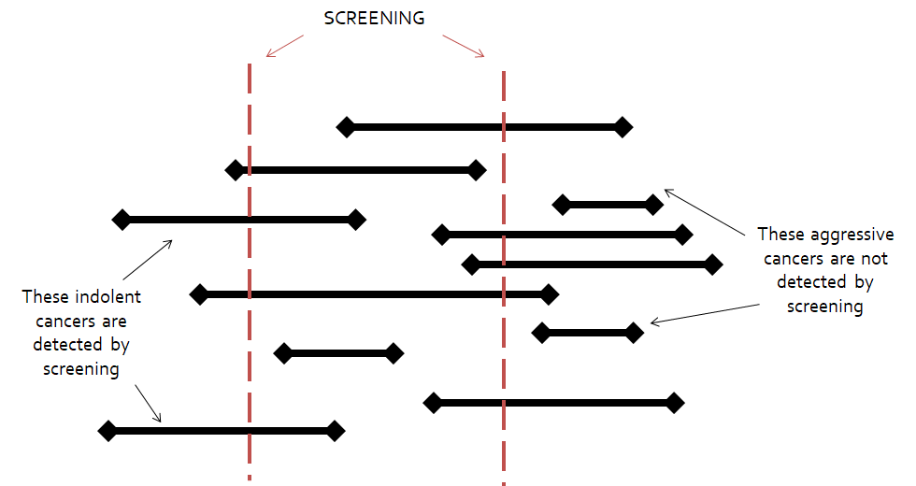

[Example]: Impotence and incontinence are common side effects of usual therapy for prostate cancer. These consequences outweigh the alternative in aggressive forms of prostate cancer. However, a considerable proportion of men with prostate cancer have slow-growing tumours that would have been unlikely to be diagnosed or cause harm but if detected and treated could unnecessarily suffer of these side effects (12).

***Selection bias***

A self-selection bias may occur because participants may be healthier and adhere better to cancer prevention recommendations, as well as to therapy when they are cancer patients. Similarly, patients with higher cancer risk because of a family history of cancer may attend more frequently to screening programs (13). Therefore the outcomes associated with these populations may be better and bias the apparent value of the screening program.

**Module 2: Cancer prevention**

# Unit: 3. Overall program characteristics

## Screening is a complex public health strategy and has several requirements to be fulfilled to be effective. Screening should be undertaken only after efficacy and, ideally, effectiveness have been evaluated and established; when resources are available and sufficient to cover a large proportion of the intended target group, when it is possible to set the required follow-up of screen-positive subjects to confirm disease and guaranty treatment options for those who are ill; and when the disease is important enough from a public health perspective to justify the effort and costs of screening.

## According to their characteristics, cancer screening programmes can be organized or opportunistic:

An **organized screening programme** is a population-based programme designed by a central public health structure (national or regional) to reach the highest possible coverage of women. All women in the target age group are invited to participate. Organized programmes comprise systematic testing with a standardized and quality assured test, a call and recall system of a well-defined target population, delivery of test results as well as additional investigations, and treatment and follow-up care if necessary. IARC defines an organized screening programme as one that has “an explicit policy with specified age categories, method, and interval for screening; a defined target population; a management team responsible for implementation; a health-care team for decisions and care; a quality assurance structure; and a method for identifying cancer occurrence in the target population” (14).

An **opportunistic or spontaneous screening** is done independently of an organized programme. In this case, women are invited to participate when visiting health services for their convenience. Screening may be recommended by a provider during a consultation or requested by a woman and it is based on the patient-practitioner relationship.

Organized screening is considered to be more efficient than opportunistic screening, given that it implies a better use of available resources and it benefits a greater number of people (15–17). Organized screening is focused on obtaining higher coverage and the quality of the process itself, providing higher benefits against screening harms. The choice of the target age group and the frequency of screening are usually made at the national or regional level. Organized screening programmes minimize inequalities in access to screening by giving every eligible person access to them. Opportunistic screening incurs more frequently in access biases, with low screening coverages in certain population groups (high-risk groups, certain ages, groups with low economic resources) and overuse in other groups. This implies a decrease in the effectiveness of the program and its profitability.

**[Practical exercise 5]** *Click the boxes below:*

Organized screening:

... is the most efficient screening delivery system in countries or settings with a publicly-funded healthcare system. Organized screening ensures high and equitable coverage, as well as high quality of the processes involved. This implies implementing an information system that identifies all individuals at risk for the disease and instituting a call-recall system to reach all members of the target age group.

... is generally accepted as more cost-effective than opportunistic screening, making better use of available resources and ensuring that the greatest number of women benefit.

Opportunistic screening

... tends to reach younger women at lower risk, for example those attending antenatal, child health and family planning services.

... tends to be inefficient, though when applied with full adherence to professional guidelines it can also achieve a high reduction in disease incidence and mortality.

**[Summary table 2]**

|  |  |
| --- | --- |
| **Organized screening** | **Opportunistic screening** |
| • Organized implementation of the diagnostic and early treatment activities in pre-defined groups of the population at risk. | • It is offered only to subjects that voluntarily attend health services, either with the purpose to get screened or for consultation reasons other than screening. |
| • The targeted population is clearly defined (subjects to be screened are identifiable). | • Its lack of organization penalizes equity, since subjects not requiring consultation do not get screened. |
| • It generally uses a census registry to invite the target population with recall systems for non-attendees. | • It creates methodological confusion between screening and clinical practice, which is hardly efficient and efficacious. |
| • Only offers validated screening techniques and has its own referral, treatment and follow-up algorithms of detected cases. | • Tends to unnecessarily repeat the screening test and sufficient levels of coverage are difficult to reach. |
| • The programme evaluation and monitoring are defined and planned, so incidence and mortality rates can be calculated separately for screening program participants and non-participants at the total targeted population level. | • Is potentially more expensive than any population-based screening design and the results of its implementation are difficult to assess. |
| • Furthermore, it establishes quality control of these epidemiological data. |  |

**[KEY MESSAGE]:** Screening is a programme, not a test.

(18) (19)

**Module 2: Cancer prevention**

**Unit:** **1.n. Summary**

* Screening consists of the systematic application of safe, easy-to-use and economically affordable tests, to provide early detection of disease. Screening aims at reducing the disease prevalence by shortening its duration, to reduce the incidence of complications associated with the disease and to increase the quality of life of those affected by the disease.
* Organized screening is a population-based programme designed by a central public health structure (national or regional) to reach the highest possible coverage of women. Opportunistic, or spontaneous screening is done independently of an organized or population-based programme: women are invited to participate when visiting health services for their convenience.
* Diagnostic test accuracy measures informs about the test ability to: 1) discriminate health and disease status in order to classify people between those who are ill and those who are not (sensitivity and specificity); 2) predict disease: estimation of the post-test probability of disease given a certain test result (predictive values).
* Several items are needed to organize a cancer screening programme, including a defined target population; defined age intervals and screening test(s) to use; a health care system with the capacity to screen, follow-up those who screened positive, and provide treatment as indicated; and quality control systems, among others.

Up until here MAXIMUM 12,5 pages

|  |
| --- |
| Title: Final Evaluation Module 2 |

**[Question 1] About cancer prevention, which of the following statements is true?**

* [Option A] Use of cytology within a cervical cancer screening programme is an example of secondary prevention.
* [Option B] HPV vaccination is an example of primary prevention.
* [Option C] Secondary prevention efforts are aimed at reducing disease incidence.
* [Option D] Screening focuses on disease detection at a clinical stage

[Correct Answer] **Option A**

**[Question 2] An screening test needs to be:**

* [Option A] Accurate and reliable
* [Option B] Acceptable and safe
* [Option C] Simple, cheap and accessible
* [Option D] All the above are correct

[Correct Answer] **Option D**

**[Question 3] What is the sensitivity of a screening test?**

* [Option A] The proportion of disease-free individuals (classified as negative by the gold standard) correctly identified by the screening test.
* [Option B] The proportion of subjects with disease (classified as positive) correctly identified by the screening test.
* [Option C] The proportion of true negatives (i.e. subjects without actual disease) among those identified by the test as negatives.
* [Option D] The probability that a subject with a negative test result has the disease.

[Correct Answer] **Option B**

**[Question 4] What is the negative predictive value of a screening test?**

* [Option A] The proportion of disease-free individuals (classified as negative by the gold standard) correctly identified by the screening test.
* [Option B] The proportion of subjects with disease (classified as positive) correctly identified by the screening test.
* [Option C] The proportion of true negatives (i.e. subjects without actual disease) among those identified by the test as negatives.
* [Option D] The probability that a subject with a negative test result has the disease.

[Correct Answer] **Option C**

**[Question 5] Which one of the following statements is not a requirement that any cancer screening test must meet?**

* [Option A] It must be a reliable and accurate test.
* [Option B] It must be economically affordable, acceptable, cause the least discomfort possible and not cause complications.
* [Option C] It must have a high specificity even if it implies low sensitivity.
* [Option D] It must be accessible to the entire target population

[Correct Answer] **Option C**

**[Question 6] Which of the following is false regarding the differences between organized and opportunistic screening programs?**

* [Option A] An opportunistic screening is more efficient that an organized screening because it makes better use of available resources.
* [Option B] An opportunistic screening can lead to inequality situations, such as an excessive screening of subjects at low risk of developing the disease and insufficient screening of those at high risk.
* [Option C] Lack of participation is the main cause of lack of success of both opportunistic or organized screening programs.
* [Option D] None of the above are correct

[Correct Answer] **Option A**

**[Question 7] Why are quality controls in cervical cancer screening important?**

* [Option A] To ensure reliability and accuracy of the results obtained through screening activities.
* [Option B] To identify possible errors or failures in the sample processing system.
* [Option C] A and B are correct.
* [Option D]None of the above are correct

[Correct Answer] **Option C**

**[Question 8] Why is it important to evaluate a cancer screening programme?**

* [Option A] To ensure the adequate programme implementation and performance throughout the territory.
* [Option B] To justify the health costs involved.
* [Option C] All are correct.
* [Option D] None of the above are correct

[Correct Answer] **Option A**

**[Question 9] Which one of the following statements is correct?**

* [Option A] Screening programs are exempt of bias
* [Option B] Lead time bias occurs because healthier participants adhere better to cancer prevention recommendations
* [Option C] Overdiagnosis bias is an form of length-time bias
* [Option D] None of the above are correct

[Correct Answer] **Option C**

**[Question 10] Which is NOT one of the 10 Wilson and Jungner principles of screening?**

* [Option A] There should be a recognizable latent or early symptomatic stage.
* [Option B] The test should be highly reliable even if it is not very acceptable to the population.
* [Option C] The condition sought should be an important health problem.
* [Option D] Facilities for diagnosis and treatment should be available.

**Module 2: Cancer prevention**

**Unit: Bibliography**

**[Bibliography]**

1. Principles of Epidemiology | Lesson 1 - Section 9 [Internet]. 2020 [cited 2020 Nov 20]. Available from: http://www.cdc.gov/csels/dsepd/ss1978/lesson1/section9.html

2. Eeles RA, Tobias JS, Berg CD, editors. Cancer prevention and screening: concepts, principles and controversies. Hoboken, NJ: Wiley; 2018. 1 p.

3. Schüz J, Espina C, Villain P, Herrero R, Leon ME, Minozzi S, et al. European Code against Cancer 4th Edition: 12 ways to reduce your cancer risk. Cancer Epidemiol. 2015 Dec;39 Suppl 1:S1-10.

4. Wilson J, Jungner G. Principles and practice of screening for disease [Internet]. Geneva, Switzerland: World Health Organization - WHO; 1968 [cited 2018 Mar 21]. Available from: http://apps.who.int/iris/bitstream/10665/208882/1/WHO_PA_66.7_eng.pdf

5. Andermann A. Revisiting Wilson and Jungner in the genomic age: a review of screening criteria over the past 40 years. Bulletin of the World Health Organization. 2008 Apr 1;86(4):317–9.

6. Gray JAM. New concepts in screening. British Journal of General Practice. 2004;7.

7. Altman DG, Bland JM. Statistics Notes: Diagnostic tests 1: sensitivity and specificity. BMJ. 1994 Jun 11;308(6943):1552.

8. Altman DG, Bland JM. Diagnostic tests 2: Predictive values. BMJ. 1994 Jul 9;309(6947):102.

9. Brenner H, Gefeller O. Variation of sensitivity, specificity, likelihood ratios and predictive values with disease prevalence. Stat Med. 1997 May 15;16(9):981–91.

10. Deeks JJ, Altman DG. Diagnostic tests 4: likelihood ratios. BMJ. 2004 Jul 17;329(7458):168–9.

11. Thomsen LT, Kjær SK, Munk C, Frederiksen K, Ørnskov D, Waldstrøm M. Clinical Performance of Human Papillomavirus (HPV) Testing versus Cytology for Cervical Cancer Screening: Results of a Large Danish Implementation Study. Clin Epidemiol. 2020;12:203–13.

12. Bunting PS. Screening for prostate cancer with prostate-specific antigen: beware the biases. Clin Chim Acta. 2002 Jan;315(1–2):71–97.

13. Cox B, Sneyd MJ. Bias in breast cancer research in the screening era. Breast. 2013 Dec;22(6):1041–5.

14. IARC. IARC Handbooks of Cancer Prevention. PREAMBLE FOR SCREENING. Lyon, France; 2009.

15. Diaz M, Moriña D, Rodríguez-Salés V, Ibáñez R, Espinás JA, de Sanjosé S. Moving towards an organized cervical cancer screening: costs and impact. Eur J Public Health. 2018 01;28(6):1132–8.

16. Schiller-Fruehwirth I, Jahn B, Einzinger P, Zauner G, Urach C, Siebert U. The Long-Term Effectiveness and Cost Effectiveness of Organized versus Opportunistic Screening for Breast Cancer in Austria. Value Health. 2017;20(8):1048–57.

17. Dubé C. Organized Screening Is Better Than Opportunistic Screening at Decreasing the Burden of Colorectal Cancer in the United States. Gastroenterology. 2018;155(5):1302–4.

18. Costas L, Frias-Gomez J, Guardiola M, Benavente Y, Pineda M, Pavón MÁ, et al. New perspectives on screening and early detection of endometrial cancer. Int J Cancer. 2019 15;145(12):3194–206.

19. Arbyn M, Anttila A, Jordan J, Ronco G, Schenck U, Segnan N, et al. European Guidelines for Quality Assurance in Cervical Cancer Screening. Second Edition—Summary Document. Annals of Oncology. 2010 Mar 1;21(3):448–58.

**Module 2: Cancer prevention**

**Unit: Additional Material**

**[Additional Material]**

* Bandos AI, Rockette HE. Use of likelihood ratios for comparisons of binary diagnostic tests: Underlying ROC curves. Med. Phys. 37 (11):5821-5830.
* Dobrow, Mark J., Victoria Hagens, Roger Chafe, Terrence Sullivan, and Linda Rabeneck. Consolidated Principles for Screening Based on a Systematic Review and Consensus Process. CMAJ 190, no. 14 (9 April 2018): E422–29. https://doi.org/10.1503/cmaj.171154.
* Hofvind S, ponti A, Patnick J, et al. False-positive results in mammographic screening for breast cancer in Europe: a literature review and survey of service screening programmes.J Med Screen. 2012;19 Suppl 1:57-66.
* Public Health England. Criteria for appraising the viability, effectiveness and appropriateness of a screening programme. Accessible at: https://www.gov.uk/government/publications/evidence-review-criteria-national-screening-programmes/criteria-for-appraising-the-viability-effectiveness-and-appropriateness-of-a-screening-programme. Last access: 20/11/2020
* World Health Organization. WHO report on cancer: setting priorities, investing wisely and providing care for all. Geneva, Switzerland: World Health Organization; 2020.
* World Health Organization. Comprehensive cervical cancer control: a guide to essential practice (2nd edition). Geneva: WHO editions., 2014